Yule-Furry process
Markov process - future is independent of the past, given the present
Linear pure-birth process - only births occur
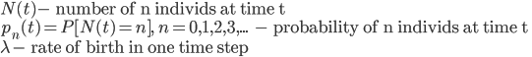
Probability of giving birth for a single individual N(t)=1:
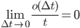
For a population of n individuals, this can happen in n ways. Thus

Two ways to get N(t)=n:
Either and 1 birth between
Or and 0 birth between
Thus:
Rearrange because we want
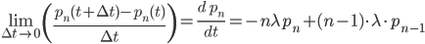
Probability of staying at n_0 given that you're at n_0?
Need to integrate: 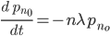
Solution is: Thus, probability of staying at same population size decreases with time and with initial population size
Probability of increasing to given that you're at n_0?
Need to integrate: 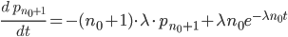
Solution is:
For a binomial distribution:
Flipping heads
Expectations=np >>>> (n=100, p=0.5, expectation = 50)
Variance =np(1-p) >>>>> (variance = 25)

